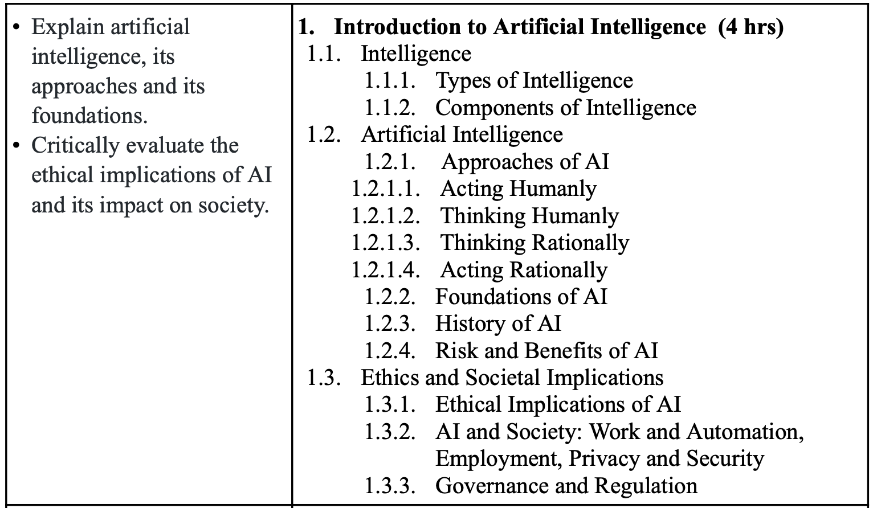

1. Define artificial intelligence. Discuss the views of AI in computer science. Also mention the application areas of AI.
2. What do you mean by intelligence? Explain that AI can act like a human with the help of “The Turing Test approach”.
3. Elaborate on the principles that guide an AI system to think and act rationally. What criteria must a machine meet to pass the Turing Test?
4. How do we ensure that an AI system thinks and acts rationally? What are the requirements for a machine to pass the Turing Test?
5. Describe the key historical milestones in the development of AI. What were the major breakthroughs, and how have these shaped the current landscape of AI research and application?
6. What are the primary risks and benefits associated with AI? Discuss the potential positive and negative impacts AI can have on various sectors, such as healthcare, education, and transportation.